Use “your” ap database (ap_*userid*).

*Screen clip your query and results below.

Each question should use only one SQL statement.

1. Create a table named terms_backup that is a copy of the terms table. (7 pts)

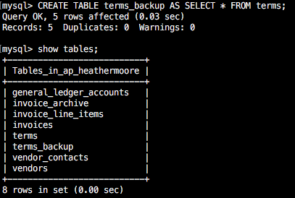

2a. Create a table named terms_backup_partial that is a copy of the terms table and contains only the rows where the terms due days are 10 – 30. (5 pts)

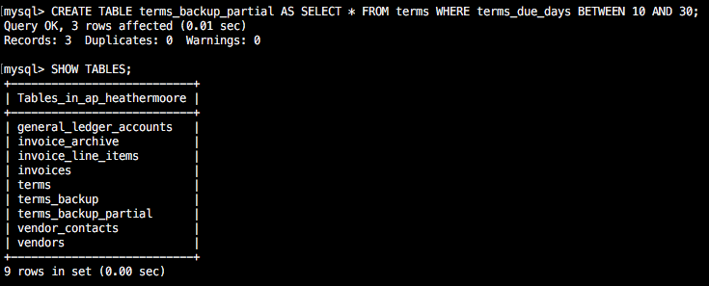

2b. Select all columns and rows from terms_backup_partial to ensure correctness. (2 pts)

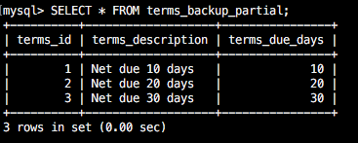

3. Delete the terms_backup_partial table. (7 pts)

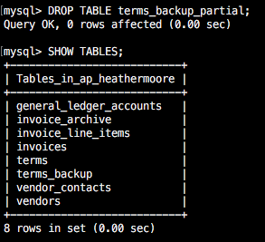

4a. Write an INSERT statement that adds this row to the terms table: (6 pts)

|  |  |
| --- | --- |
| terms_id | 6 |
| terms_description | Net due 120 days |
| terms_due_days | 120 |

**Screen Shot 2017-06-13 at 10.19.46 AM.png**

4b. Select all rows and records from the terms table to see your record. (2 pts)

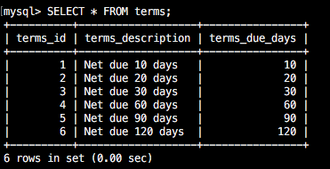

5a. Write an UPDATE statement that modifies the row you just added to the terms table. This statement should change the terms_description column to “Net due 125 days”, and it should change the terms_due_days column to 125. (6 pts)

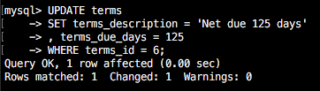

5b. Select all rows and records from the terms table to see your updated record. (2 pts)

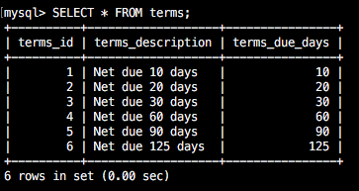

6a. Write a DELETE statement that deletes the row you added to the terms table in Q4. (6 pts)

Screen Shot 2017-06-13 at 10.26.15 AM.png

6b. Select all rows and records from the terms table to see your record is no longer there. (2 pts)

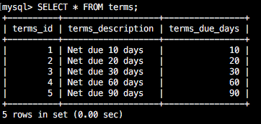

7. Write an INSERT statement that adds this row to the Invoices table and not use a column list or a SET: (7 pts)

|  |  |
| --- | --- |
| invoice_id | the next automatically generated ID |
| vendor_id | 32 |
| invoice_number | AX-014-027 |
| invoice_date | 8/1/2011 |
| invoice_total | $434.58 |
| pament_total | $0.00 |
| credit_total | $0.00 |
| terms_id | 2 |
| invoice_due_date | 8/31/2011 |
| payment_date | null |

**Screen Shot 2017-06-13 at 10.32.38 AM.png**

**I realized after putting this in that the dates didn’t set because I didn’t put quotes around them. I did an update to fix that.**

7b. Check your work by selecting all columns, ordering them in reverse by the invoice_id and limiting the output to 5. SELECT * from invoices ORDER BY invoice_id DESC LIMIT 5; (2 pts)

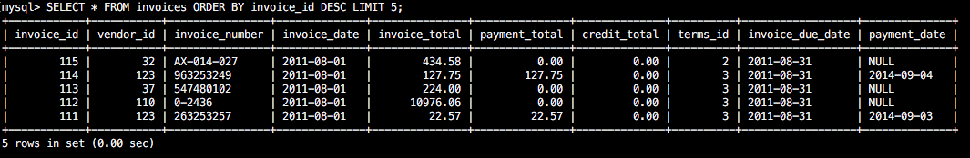

8a. Write an INSERT statement that adds these 2 rows to the invoice_line_items table: (7 pts)

|  |  |  |
| --- | --- | --- |
| invoice_sequence | 1 | 2 |
| account_number | 160 | 527 |
| line-item_amount | $180.34 | $254.35 |
| line_item_description | Hard Drive | Exchange Server update |

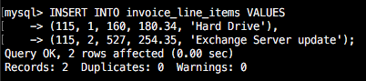

8b. Check your work: SELECT * FROM invoice_line_items ORDER BY invoice_id DESC LIMIT 5; (2pts)

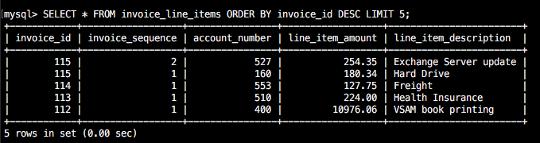

9a. Write an UPDATE statement that modifies the invoice you added in Q7. This statement should change the credit_total column so it’s 10% of the invoice_total column, and it should change the payment_total column so the sum of the payment_total and credit_total columns are equal to the invoice_total column. It is ok to get a warning on this statement as the math causes the decimal places to go long and it will truncate to the definition. (7 pts)

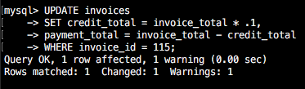

9b. Check your work: SELECT * from invoices WHERE invoice_id = 115; Notice that you should now have a payment_total and a credit_total … look at 7b, these columns were zeroes before. (2 pts)

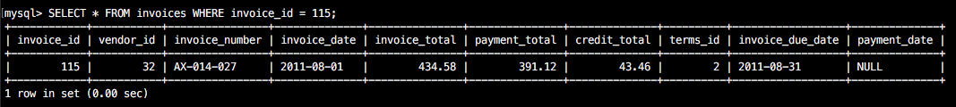

10a. Look at vendor with an ID of 44 because you will update this vendor record in 10b. SELECT * FROM vendors WHERE vendor_id = 44;



10b. Write an UPDATE statement that modifies the Vendors table. Change the default_account_number column to 403 for the vendor with an ID of 44. (7 pts)

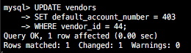

10c. Check your work by re-executing statement from 10a. (2 pts)



11. Write an UPDATE statement that modifies the Invoices table. Change the terms_id column to 3 for each invoice that is for a vendor with a default_terms_id of 2.

HINT: First figure out how many records should be updated by finding all the invoices that belong to vendors whose default_terms_id = 2; There should be 18 rows and you should see that all the terms_id are equal to 2.

SELECT invoice_id, terms_id FROM invoices WHERE vendor_id IN (SELECT vendor_id FROM vendors WHERE default_terms_id = 2);

Now write your update statement, using the subselect from above. (7 pts)

Screen Shot 2017-06-13 at 11.23.14 AM.png

Now re-run the SELECT statement from above to verify that the terms_id for these invoices were all changed to 3. (2 pts)

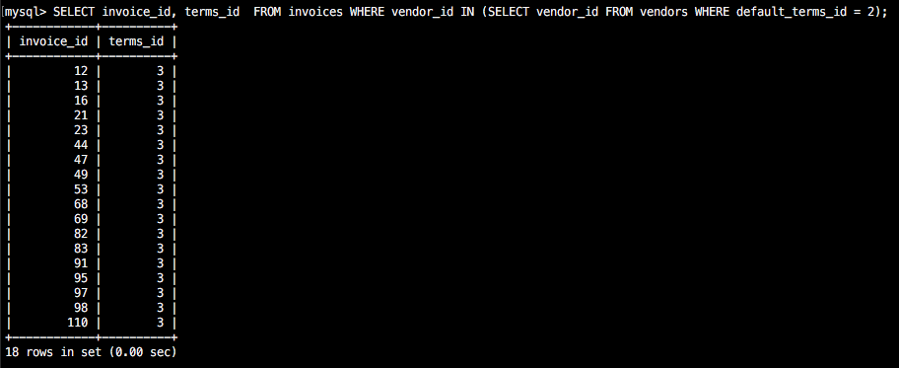

12. Write a DELETE statement that deletes the row that you added to the Invoices table in Q7. When you execute this statement , it will produce an error since the invoice has related rows in the invoice_line_items table. Show this error.



To fix that, precede the DELETE statement with another DELETE statement that deletes the line items for this invoice. There should be a total of 3 rows deleted, two from invoice_line_items and one from invoices. (10 pts)

Screen Shot 2017-06-13 at 11.50.10 AM.png

Screen Shot 2017-06-13 at 11.50.42 AM.png